What are Statements, Expression and Operators in C#?
A C# program is a set of tasks that perform to achieve the overall functionality of the program.
To perform the tasks, programmers provide instructions. These instructions are called statements.
Statements are referred to as logical grouping of variables, operators, and C# keywords that perform a special task.
A C# program contains multiple statements grouped in blocks. A block is a code segment enclosed in curly braces. {}
Statements in C#
Statements are used to specify the input, the process, and the output tasks of a program. Statements can consist of -:
- Data types
- Variables
- Operators
- Constants
- Literals
- Keywords
- Escape Sequence Characters
Statements help you build a logical flow in the program. With the help of statements, you can -:
- Initialize variables and objects
- Take the input
- Call a method of a class
- Display the output
Similar to statements in C and C++, the C# statements are classified into several categories:
- Selections Statements
- Iterations Statements
- Jump Statements
- Exception Handling Statements
Expression in C#
Expressions are used to manipulate data. Like in mathematics, expression in programming languages,
Including C# are constructed from the operands and operators.
Example -: 2 + 2 (Here 2 is an operand and + is a operators)
An expression statements in C# ends with a semicolon (;).
The Flowing code demonstrates an example for expression:
simple Interest = principal * time * rate / 100;
Operators in C#
Expressions in C# comprise one or more operators that performs some operations on variables.
An operation is actions perform on single or multiple values stored in variables in order to modify them or to generate a new value with the help of minimum one symbol and a value.
The symbol is called an operator and it determine the type of action to be performed on the value.
An operand might be a complex expression.
For example, (X * Y) + (Y – X) is a complex expression, Where the + operator is used to join two operands.
The value on which the operation is to be performed is called an operand.
Operators are used to simplify expressions in C#; there is predefined set of operators used to perform various types of operations.
Classification of Operators
Operators are classified in 3 categories:
- UNARY OPERATORS
- Unary Operators are those operators that operate on a single operand to perform an operation like increment, decrement, negation, or logical NOT.
They change or return a new value based on only one variable or constant.
- BINARY OPERATORS
- Binary Operators are operators that act on two operands (values or variables) to perform a specific operation such as addition, subtraction, multiplication, comparison, or logical operation.
- ➡️ In simple words:
Binary operators need two values to work, e.g., a + b, x > y, num1 && num2.
- TERNARY OPERATORS
- Ternary Operator is an operator that works on three operands.
It is also known as the Conditional Operator and is used to make decisions in a single line.
These are classified into seven categories based on the action the perform on values:
- Arithmetic Operators
- Relational Operators
- Logical Operators
- Bitwise Operators
- Conditional Operators
- Increment and Decrement Operators
- Assignment Operators

Arithmetic Operators in C#
Arithmetic Operators are binary operators because they work with two operands, with the operator being placed in between the operands.
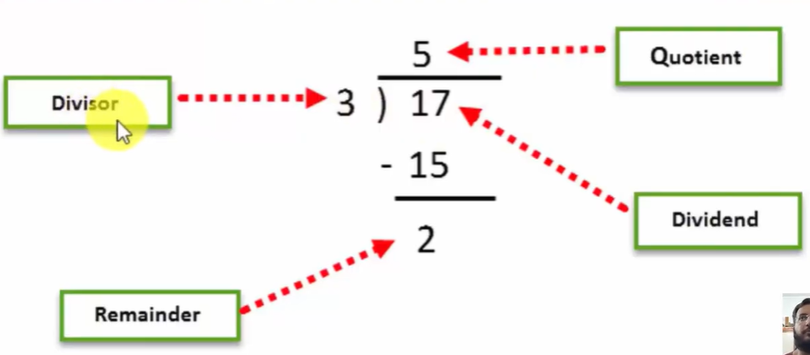
+ (addition)
- (subtraction)
* (multiplication)
/ (division)
% (modulus)

Relational Operators in C#
Relational Operators make a comparison between two operands and return a Boolean value, true or false.
== (double equal to)
! = (not equal to)
> (greater than)
< (less than)
>= (greater than equal to)
<= (less than equal to)

Logical OR Conditional Operators in C#
Logical Operators perform Boolean logical operations on both the operands. They return a Boolean value based on the logical operator used.
There are two types of conditional operators.
Conditional AND (&&) Conditional OR (||).
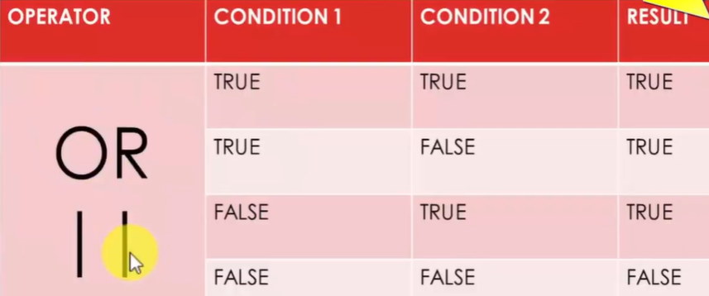
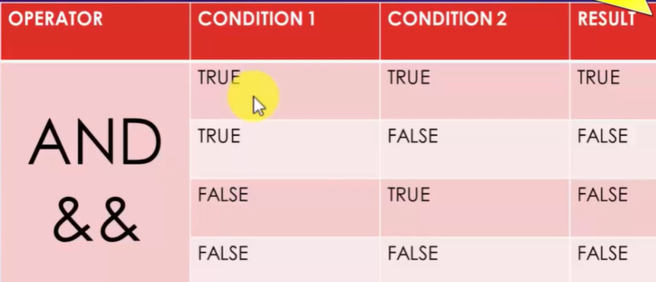

Assignment Operators in C#
Assignment Operator are used to assign the value of the right-side operand to the operand on the left side using the equal to operator (=).
Int a = 20;
The assignment operators are divided into two categories in C#. These are as follows.
Simple assignment operators. The simple assignment operator is =,
which is used to assign a value or result of an expression to a variable.
Compound assignment operators: The compound assignment operators are formed by combining the simple assignment operator with the arithmetic operators.
Compound assignment Operators:
+=
-=
*=
/=
%=
Increment & Decrement Operators in C#
Two of the most common calculations performed in programming are increasing and decreasing the value of the variable by 1.

